VEX V5 Override: Session 3 - Driving Test
Activity: Drive in a figure eight pattern around the Goals on the Field.
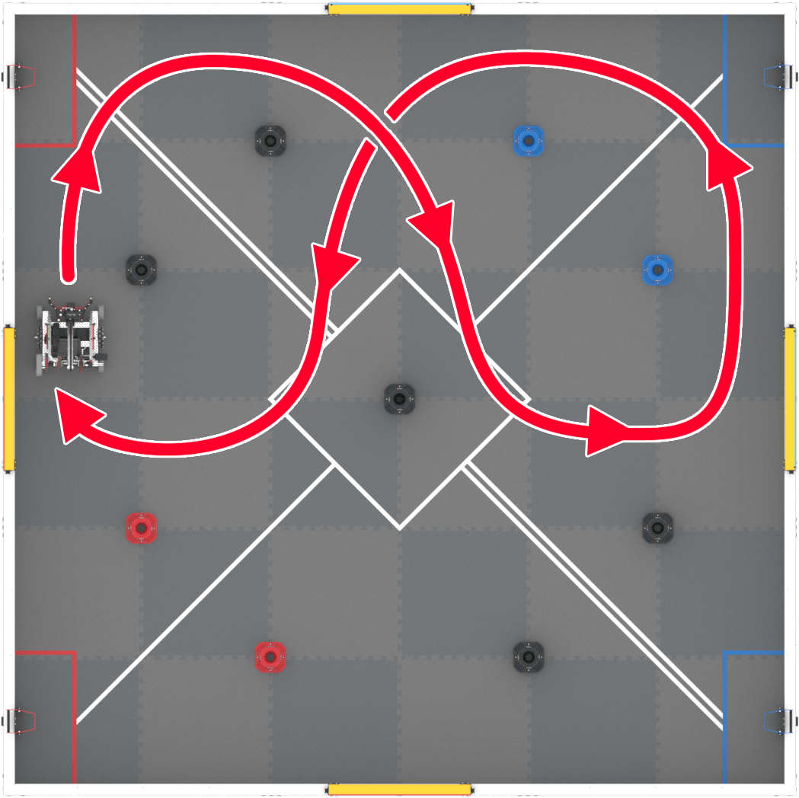
- Set up for the activity:
  - Make sure the Controller is paired with the robot. Use the information in this article to help you.
  - Set up your field as shown in the image to the right. You do not need any pins on the field for this activity.
  - Start the Drive program on the VEX V5 Brain.
- You will test all four configurations and see how long it takes to drive in a figure eight pattern around the Goals on the Field.
  - Time how long it takes to complete the drive path.
  - Record your time and any other notes about the task in your engineering notebook.
- Place Flex back into the same starting position. Repeat the test with each of the controller configurations.
  - Record the time and notes for each controller configuration.
Example Documentation: On the following page.
Remember, this is just one way to document your data. Document in the way that works best for you!

Feeling Stuck? Slow down and practice driving forward, backward, left, and right before beginning the task. Maybe this controller configuration isn’t for you. You will also improve over time!

Discussion Questions  - What do you like about each configuration?  - What do you dislike?  - How can you improve your driving or documentation skills? | Activity Checklist  - Each team member drove the drive path with all four configurations.  - Each team member recorded drive data in the engineering notebook.

Example Documentation

Remember, this is just one way to document your data. Document in the way that works best for you!
Task: Drive in a figure eight pattern around the Goals on the Field!

Driver | Configuration | Joystick Controls | Time
Lauren | Dual  (Tank Drive) | 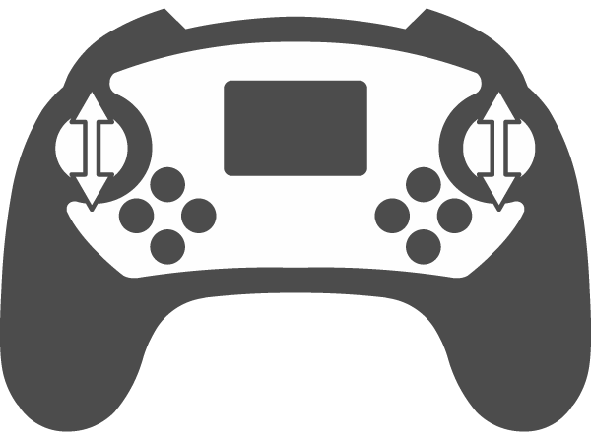  Left motor with left joystick  Right motor with right joystick | 32 seconds
Lauren | Notes:
Lauren | Left Arcade
Lauren | Notes:
Lauren | Right Arcade
Lauren | Notes:
Lauren | Split Arcade
Lauren | Notes:

